Coursera

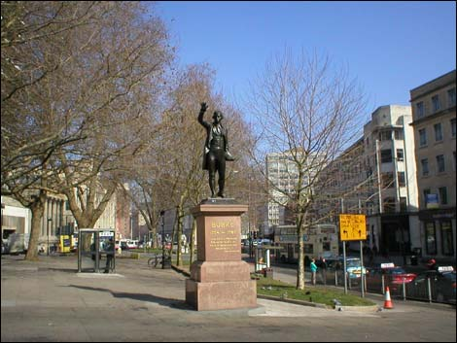Applied Data Science Capstone

Finding the best place for an Indian restaurant in Bristol

By Tanya Taylor

**Introduction**

Bristol was originally called Brigg stow, which means the meeting place at the bridge in old Saxon. Bristol is a multicultural University city 120 miles west of London and is the largest city in the southwest of England. It has a population of 459000 and a student population of 54000 from its two universities and has 187 countries of birth. It has a good tradition in restaurants with 5 Michelin starred restaurants and received the award of Best Culinary destination in the World Food Travel Association Food Trekking Awards 2019.

Indian cuisine is very popular in Britain with curry being its 4th favourite food before pizza. The first curry house in Britain was 200 years ago and Queen Victoria, in the height of British Imperialism in India, made it fashionable as she had Indian staff who cooked Indian food everyday. It became more recently (after 1971) popular after the war in Bangladesh, made many Bangladeshis move to Britain and now they dominate the curry industry (65-75%). Now curry is the fourth favourite food in Britain before pizza and Chicken Tikka Massala is actually a british national dish and was actually created in Glasgow in Scotland in 1971 in Shish Mahal restaurant, the story is that a bus driver ordered the chicken curry but complained when it arrived that it was too dry, so the chef added tomato soup and some extra herbs and that is how the dish was formed.

Going to a restaurant is one of the most popular activities to celebrate events like birthdays, anniversaries, christmas etc. People also go to restaurants to do business meetings, to avoid cooking and to rest after a busy shopping trip.

**Business Problem**

In this study I would like to determine a suitable site for a new Indian restaurant within Bristol.

In order to determine a suitable site we need to consider where Indian restaurants are already established compared to the population density in that area. The restaurant needs to be located in an area where there are not already a high number of restaurants per populaton. It also needs to be within easy reach of a train station or a car park and ideally close to busy shopping areas.

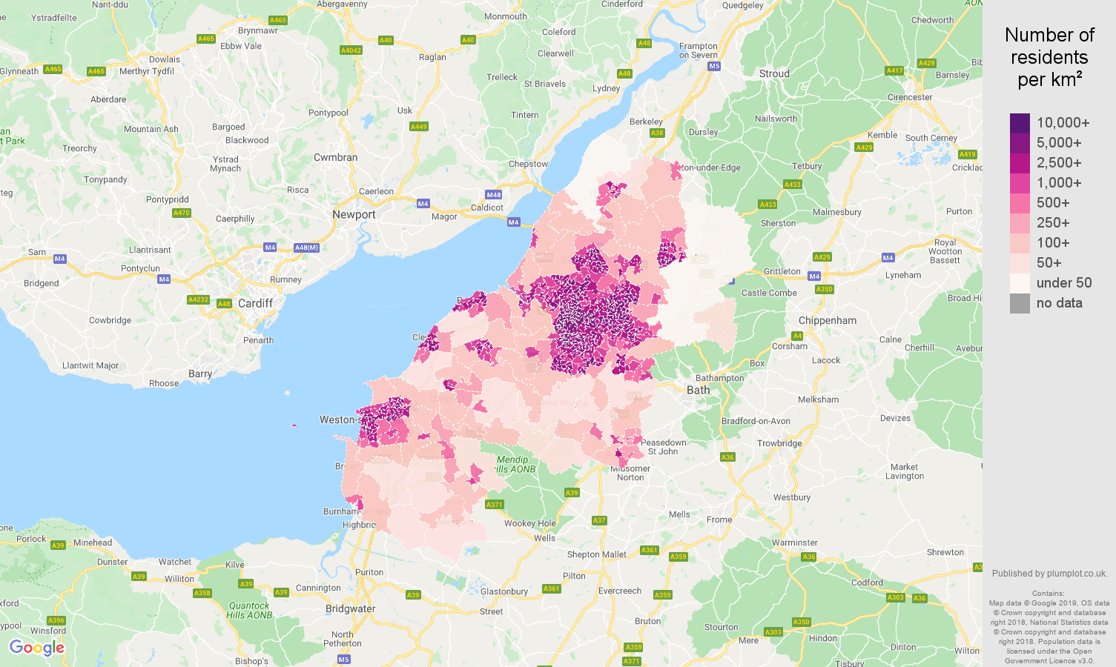

This is a map of the Bristol area showing the number of residents per km3, therefore the population density.

**Target audience of this project**

The project looks at the most suitable location to position an Indian restaurant within the Bristol postcode area using the proximity of established restaurants within the Bristol area. The study is aimed at anyone considering establishing an Indian restaurant within the Bristol area. This may be a property investor or a first-time entrepreneur.

**Data**

To investigate the problem, we will need the following data:

* Postcodes within the Bristol area, which defines the scope of the project
* Latitude and longitude coordinates of the postcode districts, this is required in order to plot the map and get the venue data.
* Venue data of restaurants within the Bristol area.

Sources of data and methods to extract them

The web page <https://www.doogal.co.uk/BuiltUpAreaSD.php?area=E35001261> has a csv file of Bristol postcodes with longitude and latitude information to download which can be loaded on to the jupyter notebook in order to form a panda dataframe. We simplified the postcode areas by finding the mean latitude for the inward codes of each outward code e.g. BS1 5RE, with the BS1 part being the outward code referring to a sector of Bristol and 5RE is the inward code referring to a street within that sector.

We use <https://www.plumplot.co.uk/Bristol-population.html> webpage to get detailed information on the population density and age distribution within Bristol.

We use the Foursquare API to retrieve venue information for the postcode districts of Bristol. The Foursquare API gives many categories of the venues (more than 105 million places in it’s database) including the location of Indian restaurants and other types of eateries. We will use Folium to do map visualisation of the location of these venues across the Bristol area. Using k-means machine learning we will examine clusters of restaurants.